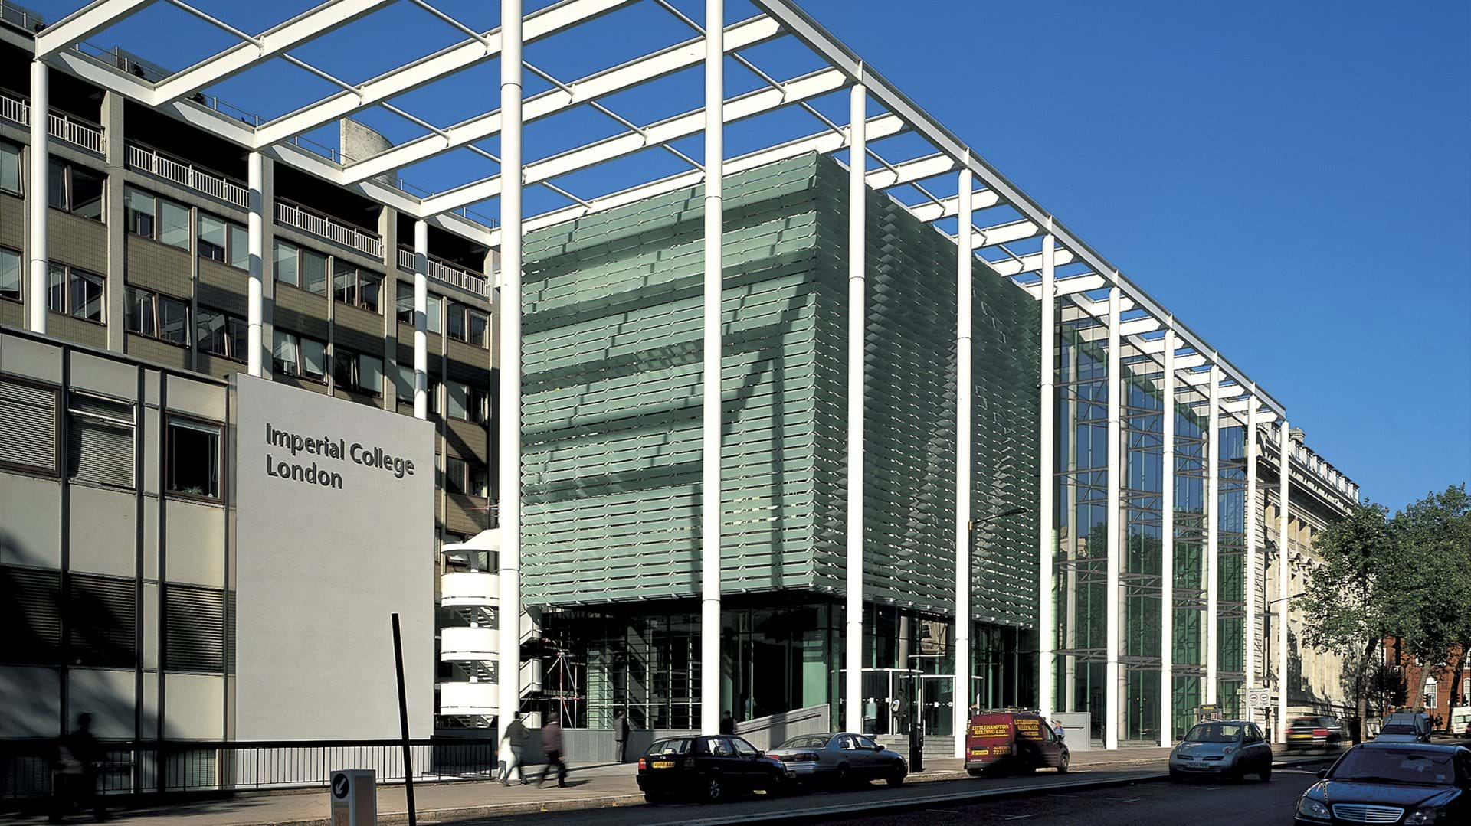

EITHiEN Conference 2019

European Perspectives

Meeting the Needs of the Health Innovation Educator

16-18 October 2019, Imperial College Business School, London UK

GENiE
Teach The Teacher

19-20 October 2019, Imperial College Business School, London UK

=====================

Wednesday, October 16th 2019
19:00 Informal Getting Together
Ognisko 55 Prince’s Gate, Exhibition Rd, London SW7 2PG
www.ogniskorestaurant.co.uk

Thursday, October 17th 2019
8:00-9:00 Registration & Coffee
9:00-9:45 Welcome & Opening
Chair/Hosts
- Francisco Veloso, Dean Imperial College Business School
- Ursula Mühle, Director, EIT Health Campus (tbc)
- Regina Herzlinger, Prof., Harvard Business School; Chair, GENiE (VC)
9:45–11:00 KEYNOTE: The Role of the Educator in Health Innovation
Chair Jaume Ribera, Prof., IESE Business School
Speaker Regina Herzlinger, Prof., Harvard Business School; Chair, GENiE (VC)
11:00-11:30 Break
11:30- 13:00 Innovation in Global Health
Moderator
- Nuria Casamitjana, ISGlobal, University of Barcelona
Panelists
- Axel Hoffmann, Swiss Tropical Institute, Basel (tbc)
- Andrea Prado, INCAE Business School (VC)
- Linda Cyr, Prof., Harvard School of Public Health
- Maureen Lewis, CEO Acceso Global
- Helen Ward, Imperial College, London
13:00-14:00 Networking Lunch

14:00-15:30 Patient Innovation
Moderator
    - Pedro Oliveira, CBS, Copenhagen Business School, DK
Panelists
    - Helena Canhao, Patient Innovation at Nova Medical School
    - Lise Pape, Patient Innovator and Entrepreneur (founder of Walk with Path)
    - Peter Bencsik, GE HealthCare Hungary
    - Filipa Fixe, Executive Board Member Glintt Portugal
15:30-16:00 Coffee Break

16:00-17:30 Operational Excellence
Moderator
    - Jaume Ribera, Prof., IESE Business School
Panelists
    - Zoe Radnor, VP Strategy Planning, City University of London
    - Wim van Harten, President of the Board of Directors of Rijnstaten Hospital, Arnhem, Zevenaar, Netherlands.
    - Jan-Olof Höög, Professor, Karolinska Institutet, Stockholm, Sweden.
17:30-17:45 Break

Thursday, October 17th 2019 (cont.)
17:45-19:00 Pitching Innovative Learning
Moderator
- Learning Innovation Unit, IESE Business School (tbc)
Pitches
- Dora Marosvolgyi, tbd
- Insittuto Pedro Nunes, Coimbra(tbc)
- EIT Health Masters
- InnoStar tech transfers
- Irene Gabutti, Rome (tbc)

20:00-22:00 EITHiEN Dinner
Speaker Helen Ward, Imperial College, Supervisory Board EIT Health (tbc)
Speaker Institute of Global Health Innovation (tbc)

Friday, October 18th 2019

8:00-9:00 Alumni Breakfast

9:15-10:45 Innovation Management
Moderator
    - James Barlow, Prof., Imperial College Business School
Panelists
    - Thomas Zelltner, IHEID - Graduate Institute Geneva and former Director-General of the Swiss National Health Authority)
    - Robert Madelin, Cyber Studies Visiting Fellow, University of Oxford, and former DG Health and Consumer Policy (SANCO) and DG Connect. Brussels.
    - Amber Kennard, Director, Health Innovation Observatory, Deloitte
    - Daniel Green, CEO ,aqrit Discovery Ltd and Principal Fellow in Entrepreneurship in the Department of Bioengineering, Imperial College
    - Andrew Ivanov, Director Centre for PPP Studies and Program for Executives “Healthcare management”, St. Petersburg University, Russia
    - Pramod Prabhakaran, International Business Development Lead, Imperial College Health Partnerships
    - Matt Harris, Consultant in Public Health Medicine, Imperial College NHS Trust

10:45-11:15 Break
11:15-12:45 Women Entrepreneurship
Moderator
- Severine LeLoarne, Grenoble School of Management
Panelists
- Klaus Diepold, TUM Munich (tbc)
- Filipa Fixe, Executive Board Member Glintt Portugal
- Janet Murray, Imperial – Coaching Women Initiative
- Monique van Dijen, Health Care & Life Science Partner, EY London (tbc)
13:00-14:00 Networking Lunch

14:00-15:30 Innovative Financing
Moderator
- Shabs Rajasekharan, Smarter Futures
Panelists
- Anant Jani, Oxford University
- Giuseppe Banfi, Hospital San Raffaele, Segrate, Italy
- Filippo Addari, Plusvalue
- Judith Town, Sheffield ACP
- Sarah Burt, NHS Sheffield CCG

Friday, October 18th 2019 (cont.)
15:30-16:00 Break
16:00-17:30 Managing Digital Transformation in Health Care
Moderator
- Kevin Schulman, Prof., Stanford Graduate School of Business
Panelists
- Paul Timmers, Cybersecurity, Oxford University
- Richard Bergstroem, Guardtimes
- Pratap Kumar, Strathmore Business School, Nairobi, Kenya
- Miklos Szocska, Semmelweiss University, Budapest (tbc)
17:30-17:45 Break
17:45-18:30 The Future of Education – Interactive Discussion
Moderator (tbc)
Discussion Session
18:30-19:00 Conclusions/Next Steps: EU & US Global Collaboration, GENiE, BAHM
- Jaume Ribera, Prof., IESE Business School
- Regina Herzlinger, Prof., Harvard Business School; Chair, GENiE (VC)
- Kevin Schulman, Prof., Stanford Graduate School of Business
(Informal Dinner )

Teach the Teacher Workshop
The GENiE Group
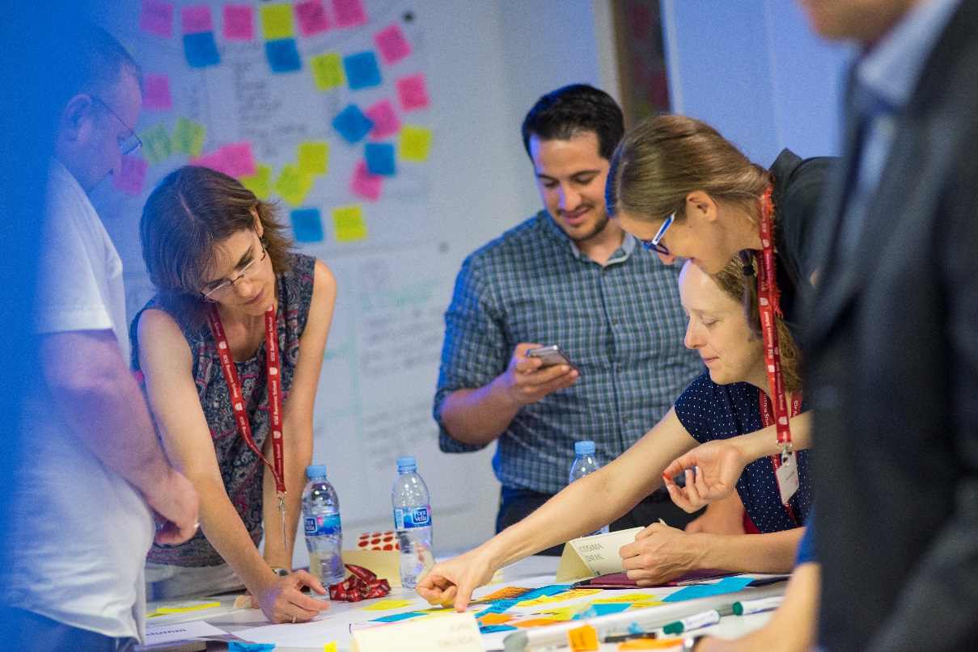
APPROACHES TO TEACHING HEALTH CARE INNOVATION
Saturday, October 19th 2019
9:00-9:30 Welcome and Introduction
Regina Herzlinger, Prof., Harvard Business School; Chair, GENiE (VC)
9:30-11:00 Identify the Health Care Venture
Regina Herzlinger, Prof., Harvard Business School; Chair, GENiE (VC)
James Wallace, Senior Associate, Harvard Business School
11:00-11:15 Break
11:15 -12:30 Innovative Problem Solving and Design Thinking in Health: Clarifying The Problem and Achieving Deep Patient/User Understanding
Linda Cyr, Prof., Harvard School of Public Health
- Distinguishing innovative problem solving from traditional approaches
- Tools for identifying pain points and developing design principles
12:30-13:00 Working Lunch (grab and return)
13:00- 14:00 Innovative Problem Solving and Design Thinking in Health: Ideating – Breaking Cognitive Fixedness And Generating Ideas
Linda Cyr, Prof., Harvard School of Public Health
- Systematic inventive thinking - Brainstorming
14:00-14:30 Break
14:30-15:00 Innovative Problem Solving and Design Thinking in Health: Developing The Concept – Making It Tangible
Linda Cyr, Prof., Harvard School of Public Health
- Prototyping
15:00-15:30 Lessons Learned
Linda Cyr, Prof., Harvard School of Public Health
15:30-16:00 Break
16:00-17:30 Assessing the Commercial Potential of Two Technology Innovations/IHC Draft Textbook
Regina Herzlinger, Prof., Harvard Business School; Chair, GENiE (VC)
17:30-18:00 Lessons Learnt. Conclusions First Day
Regina Herzlinger, Prof., Harvard Business School; Chair, GENiE (VC)

Sunday, October 20th 2019
9:00-9:30 Breakfast
9:30-11:00 Health Stop (A), Health Stop (B)
James Wallace, Senior Associate, Harvard Business School /, GENiE
- Will Health Stop succeed and why?
- Which of the other retail medical centers is the most and least likely to succeed and why?
- How can Health Stop improve its performance?
11:00-11:30 Break
11:30-13:00 Phreesia
James Wallace, Senior Associate, Harvard Business School /, GENiE
Michael Weintraub, Chairman, Phreesia; Executive in Residence, Harvard Business School
13:00-14:00 Working Lunch (grab and return)
14:00-15:00 Organizing Your School for Teaching Innovations in Health Care
Frank Sutter, Associate Director, Health Care Initiative, Harvard Business School
Steve Bonner, Executive in Residence, Harvard Business School
James Barlow, Prof., Imperial College Business School
Jaume Ribera, Prof., IESE Business School
15:00-15:30 Lessons Learned/Evaluations
Regina Herzlinger, Prof., Harvard Business School; Chair, GENiE (VC)
Jaume Ribera, Prof., IESE Business School

